Project Description

A prototype to Company Lockers Pvt. Ltd. The application is having 5 options to accept user input.

1. Retrieve all file in ascending order
2. Create new file based on user input file name
3. Delete file based in user input file name
4. Search the file based on user input file name
5. Exit the application

Screenshot 1: user interface

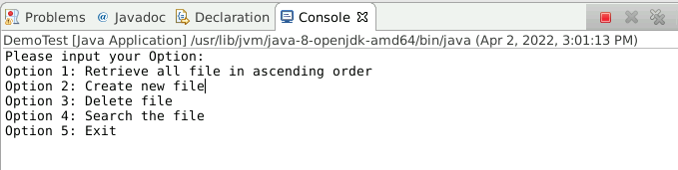

Option 1 result:

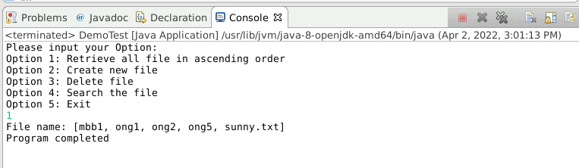

Option 2 result:

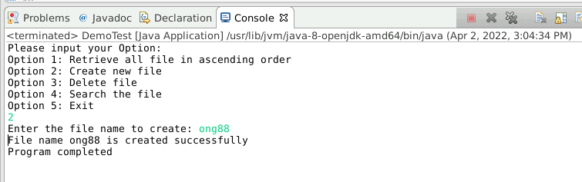

Option 3 result:

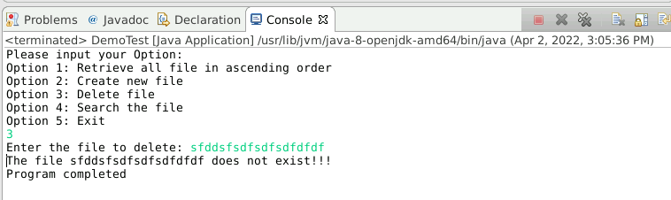

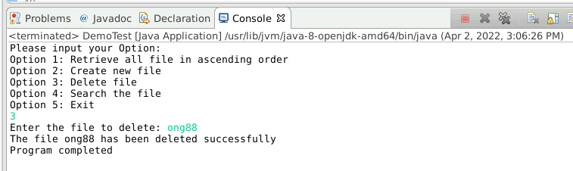

Option 4 result:

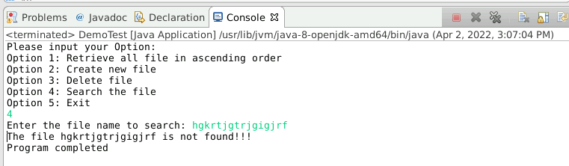

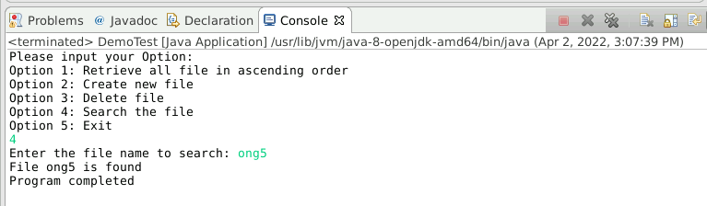

Option 5 result:

